**Content fixed**

Boguensa_temple

------------

+Located in the heart of ritzy Gangnam 531 Bongeunsa-ro.

+Founded in AD 794, the buildings have been rebuilt many times over the centuries.

+ Entry to the temple is through Jinyeomun (Gate of Truth), protected by four king guardians.

+The main shrine, Daewungjeon has lattice doors and is decor­ated inside and out with Buddhist symbols and art that express Buddhist philosophy and ideals.

+Make an effort to visit on Thursday when monks and volunteers offer the [templelife program](https://www.lonelyplanet.com/pois/1409842) in English

+There's also an opportunity to stay overnight in the two-day templestay program (₩70,000)

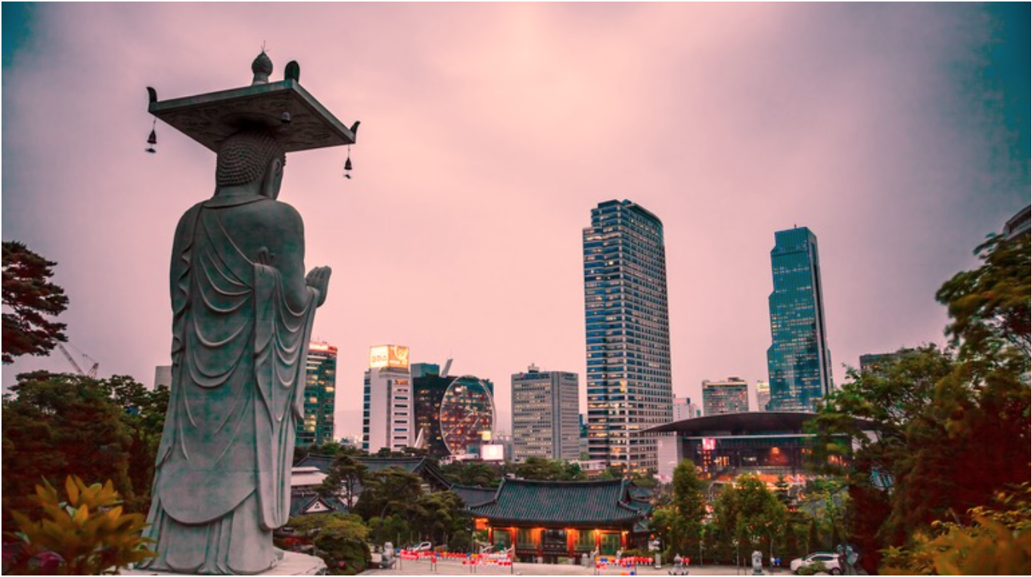

Lotte World

----------------

+240 Olympic-ro, Songpa-gu

+9am-10pm

+This huge complex includes an amusement park, an ice-skating rink, a cinema multiplex, department store, folk museum, shopping mall, hotel, restaurants and more

+basically an indoor Korean version of Disneyland

+The [Folk Museum](https://www.lonelyplanet.com/pois/1099163) uses imagin­ative techniques like dioramas, scale models and moving waxworks to bring scenes from Korean history to life.

+The price is included in the day-pass ticket for Lotte World Adventure and Magic Island.

+Adult/Youth/Child 31000/28000/25000

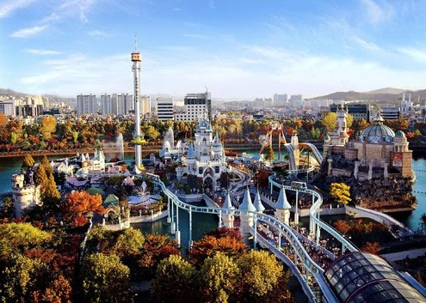

Olympic park

-----------------

+424 Olumpic-ro Songpa-gu

+This large and pleasant park was the focus of the 1988 Olympics

+There's a gallery of modern art and two museums on the history of the Baekje dynasty

+On Wednesdays and Thursdays between March and December, motor boats race three times round a 600m course at Misari (20km east of Seoul) while gamblers watch the races on screens.

+Scattered like buckshot around the park are over 200 sculptures, some larger than a house. Designed and made by sculptors from around the world

+The [Olympic Museum](https://www.lonelyplanet.com/pois/1099137) has screens showing the exciting highlights of the 1988 Seoul Olympics, together with a brief history of the Olympics.

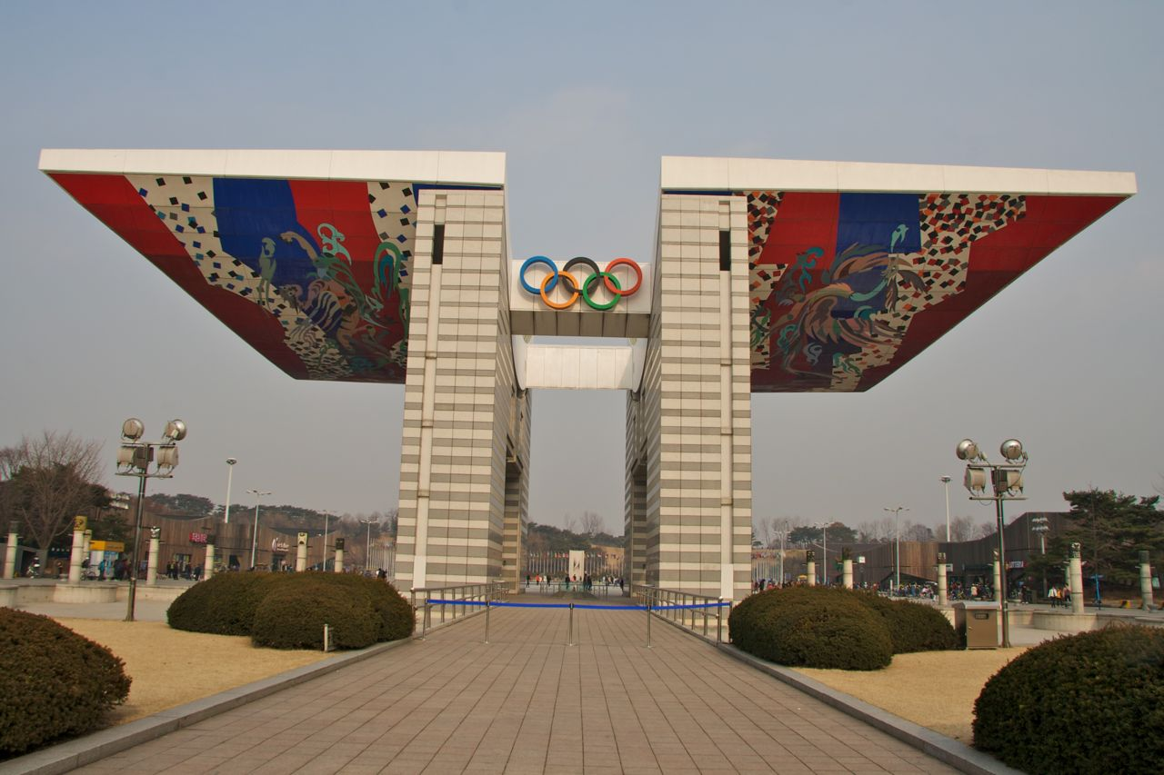

Sungnyeymun gate

-------------------------

+29 Namdaemunno 4-ga

+9pm-6pm Tue-Sun .

+Sungnyemun is one of the capital's original four main gates built in the 14th century.

+It's been reconstructed a number times over the years following damage under Japanese occupation and during the Korean War, and most recently after an arson attack in 2008.

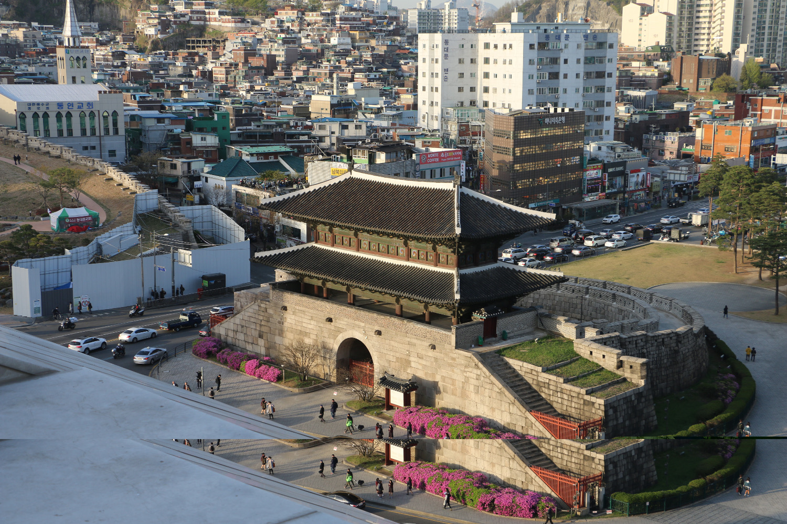

Seoul Worldcup Statium

-------------------------------

+240 Woldeukeom-ro 9am-6pm

+Adult/Child 1000/500

+The Seoul World Cup Museum at the [World Cup Stadium & Mall](https://www.lonelyplanet.com/pois/1409381) relives the highs and lows of the 2002 cup on screen, along with souvenirs and a couple of virtual football games.

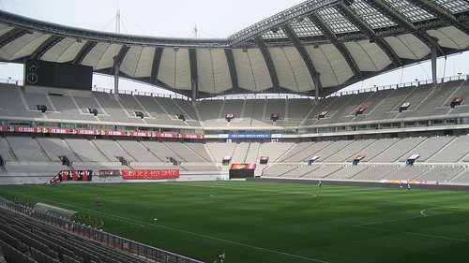

Namsan Seoul Tower

----------------------------

+Namsan Seoul Korea

+10am-11pm

+Adult/Child 9000/7000

+The iconic N Seoul tower (236m), atop the city’s guardian mountain Namsan

+Come at sunset and you can watch the city morph into a galaxy of twinkling stars.

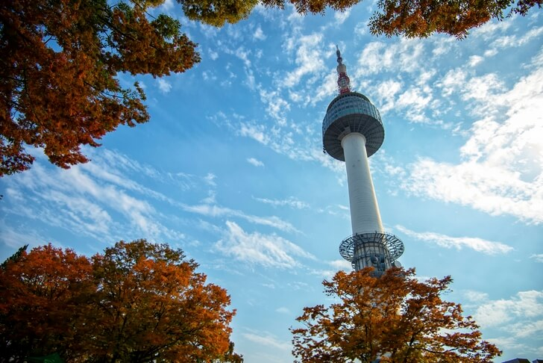

Gyeongbokgung Palace

------------------------------

+9am-5pm Wed-Mon Nov-Feb, to 6pm Mar-May, Sep & Oct, to 6.30pm Jun-Aug

+Adult/Child 3000/1500

+Originally built by King Taejo, the founder of the Joseon dynasty, Gyeongbokgung served as the principal palace until 1592

+Altogether the palace consisted of 330 buildings and had up to 3000 staff, including 140 eunuchs, all serving the royal family.

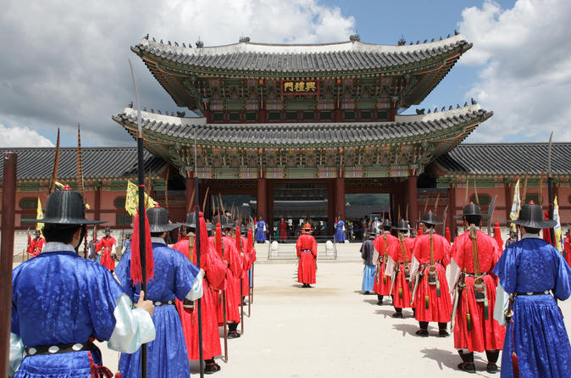

Bukchon Hanok Village

------------------------------

+Meaning ‘North Village’, Bukchon, between Gyeongbokgung and Changdeokgung, is home to around 900 *hanok,* Seoul’s largest concentration of these traditional Korean homes.

+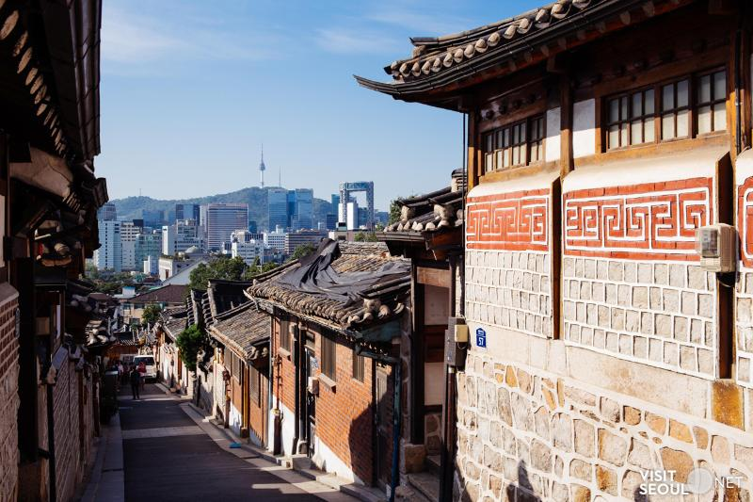

Lotte Tower

----------------

+300 Olympic –ro Songpa-gu

+Due for completion in late 2016, Seoul's latest landmark is the 555m-high Lotte World Tower – the tallest skyscraper in Korea (and 6th highest in the world). Its sleek contemporary design is loosely inspired by traditional Korean ceramics, and will feature the world's highest observation deck with a glass-floored skywalk, art gallery, cafe, six-star hotel and the mega [Lotte World Mall](https://www.lonelyplanet.com/pois/1514871) complex.

